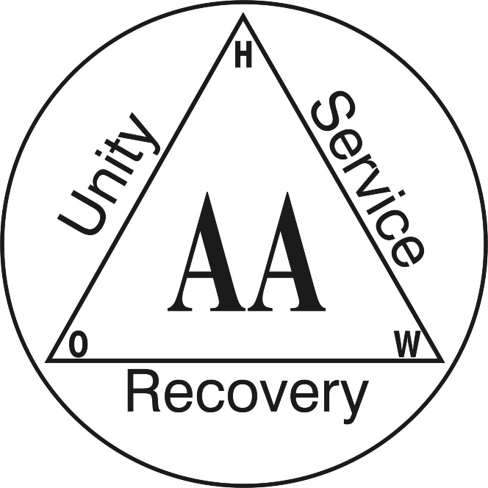

Please join us for the first meeting of the new Berkshire County CPC:

Cooperation with the
Professional Community
Monday, Dec 9th at 6 pm at the
Berkshire Intergroup Office
152 North Street, Suite 30C
Pittsfield, MA 01201

